25 February 2025

TENDER ACCEPTANCE LETTER
Client: City of Tshwane
Tender Number: HHS 10 – 2023/24

Dear Sir/Madam,

On behalf of Livhu and Musa Enterprise, I am pleased to confirm our acceptance of the appointment for the tender titled:
"Tender for the Appointment of Service Providers for the Hire of Mobile Drinking Water Tankers (Trucks) with the Loading Capacity of Between 10,000 to 15,000 Litres of Water for Supply in the Informal Settlements in the City of Tshwane: Three (3) Year Period: As and When Required: With Effect from 15 February 2025 or Nearest Date."
We are committed to fulfilling all the requirements and responsibilities outlined in the tender documents and look forward to a successful partnership with the City of Tshwane. Our team is prepared to commence operations on the nearest feasible date as stipulated.

Should you require any further information or clarification, please do not hesitate to contact us.
Thank you for this opportunity.

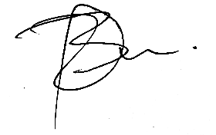
……………………………………………
MR. B.D LUKHELE
Director

